計算機組織期中考重點提示

- Digital logicl fundamentals. Combinatorial and sequential logics. (truth table, Karnaugh map, state diagram/table, Mealy and Moore machines and their construction methods, counters, and various flip flops.)

- Sequential circuit examples: Modulo 6 counter, string checker, tool booth.

- Various methods to construct the sequential logics. (Using combinatorial logic, using ROM, and using counter).

- What is ISA? The ISA of Relative Simple CPU and 8085.

- Write simple assembly programs of Relative Simple CPU and 8085. (very simple program)

- Instruction cycle, isolated/memory-mapped I/O, types of RAM and ROM.

- Internal chip organization. (high/low -order interleaving).

- Memory subsystem organization (extend word size, extend number of words, the enable logic).

- Enable/load logic for I/O.

- DMA, interrupt, and wait states.

- Fig. 4-13 and 4-14.

出題基本上來自以上重點。有看此提示者，點擊"老師信箱"給我個回信；之前上課情況不佳，同學或許是有些意見，歡迎在來信說明(比如太快，用投影片不習慣，希望多寫重點等等)。
Chapter 2

22.
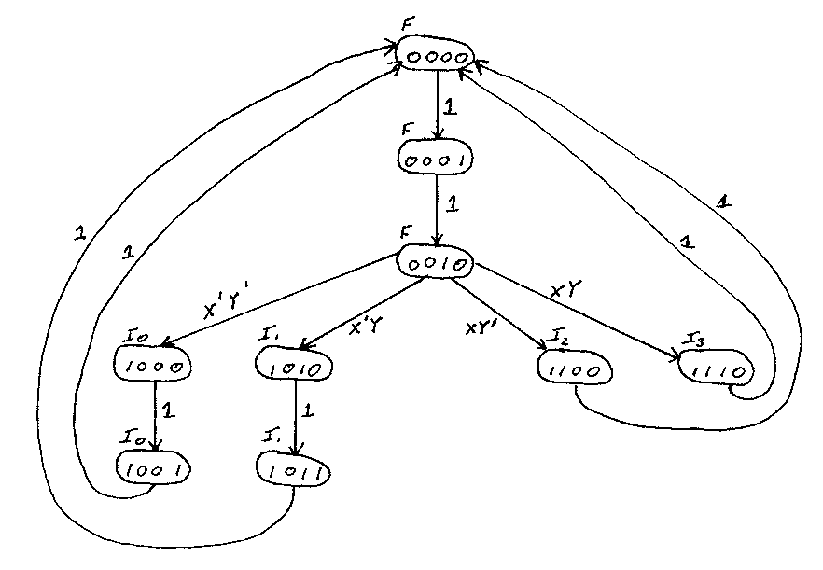

24.
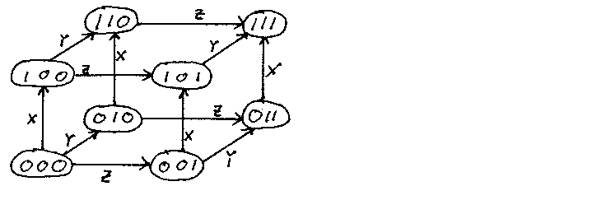

Chapter 3.

1. a) Data movement b) Data operation c) Program control d) Data operation e) Data operation

3. a) Direct b) Implied c) Implicit

6. a) Register Direct b) Immediate c) Implicit d) Immediate e) Direct

9. a) AC = 11 b) AC = 12 c) AC = 10 d) AC = 11 e) AC = 10 f) AC = 33 g) AC = 41

15. | Processor | Time per instruction | # Instructions | Total time
 | 0 | 35 ns | 4 | 140 ns
 | 1 | 50 ns | 3 | 150 ns
 | 2 | 70 ns | 2 | 140 ns
 | 3 | 100 ns | 1 | 100 ns | ← fastest

19. |  | LDAC 1001H  MVAC  LDAC 1002H  ADD  MVAC  LDAC 1003H  ADD  MVAC  LDAC 1004H  ADD  MVAC  LDAC 1005H  ADD  MVAC |  | LDAC 1006H  ADD  MVAC  LDAC 1007H  ADD  MVAC  LDAC 1008H  ADD  MVAC  LDAC 1009H  ADD  MVAC  LDAC 100AH  ADD  STAC 1000H

20. | Loop: | LXI H, 1001H  MVI B,0AH  XRA A  ADD M  INX H  DCR B  JNZ Loop  STA 1000H

